Name | Siddhesh Sonar
UID no. | 2021700063
Experiment No. | 5

AIM: | To implement Matrix Chain Multiplication
Program
PROBLEM STATEMENT : | To implement Matrix Chain Multiplication
ALGORITHM/  THEORY: | Matrix chain multiplication is an optimization problem concerning the most efficient way to multiply a given sequence of matrices. The problem is not actually to perform the multiplications, but merely to decide the sequence of the matrix multiplications involved.  Begin  define table minMul of size n x n, initially fill with all 0s  for length := 2 to n, do  fir i:=1 to n-length, do  j := i + length – 1  minMul[i, j] := ∞  for k := i to j-1, do  q := minMul[i, k] + minMul[k+1, j] + array[i-1]*array[k]*array[j]  if q < minMul[i, j], then minMul[i, j] := q  done  done  done  return minMul[1, n-1]  End
PROGRAM: | #include <limits.h>  #include <stdio.h>  #include <stdlib.h>  #include <string.h>  void print_parentheses(int s[][5], int i, int j) {  if (i == j) {  printf("A%d", i);  return;  }  printf("(");  print_parentheses(s, i, s[i][j]);  print_parentheses(s, s[i][j] + 1, j);  printf(")");  }  int matrixmin(int p[], int n) {  int m[n][n];  int s[n][n];  memset(m, 0, sizeof(m[0][0]) * n * n);  int i, j, k, L, q;  for (L = 2; L < n; L++) {  for (i = 1; i < n - L + 1; i++) {  j = i + L - 1;  m[i][j] = INT_MAX;  for (k = i; k <= j - 1; k++) {  q = m[i][k] + m[k + 1][j] + p[i - 1] * p[k] * p[j];  if (q < m[i][j]) {  m[i][j] = q;  s[i][j] = k;  }  }  }  }  printf("\nm Table:\n");  for (i = 1; i < n; i++) {  for (j = 1; j < n; j++) {  printf("%d ", m[i][j]);  }  printf("\n");  }  printf("\ns Table:\n");  for (i = 1; i < n - 1; i++) {  for (j = 2; j < n; j++) {  if (i < j) {  printf("%d ", s[i][j]);  } else {  printf(" ");  }  }  printf("\n");  }  printf("\nOptimal Multiplication: ");  print_parentheses(s, 1, n - 1);  printf("\n");  return m[1][n - 1];  }  int main() {  int arr[] = {1, 2, 3, 2, 1};  int size = sizeof(arr) / sizeof(arr[0]);  printf("\nMinimum cost = %d\n", matrixmin(arr, size));  return 0;  }
RESULT:

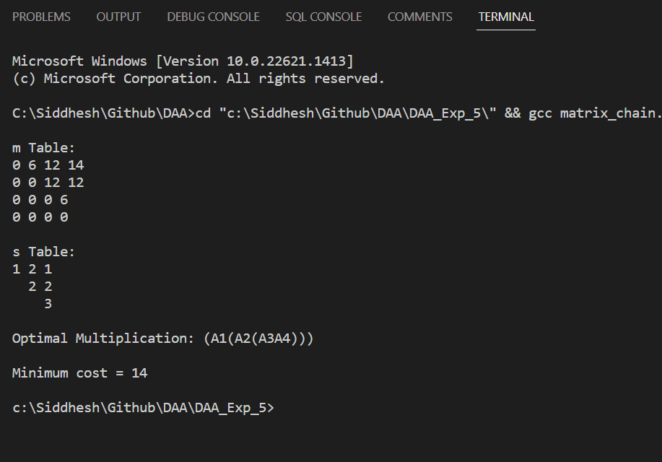
CONCLUSION: | Successfully understood Matrix Chain Multiplication algorithm and implemented it in C program to find the minimum number of steps for multiplication of 2 matrices.

